**IP Addresses**

IP has two different versions: version four and version six. Version four is the one that is supported across all AWS products and services but version six has been slowly introduced and currently has partial support across some AWS products.

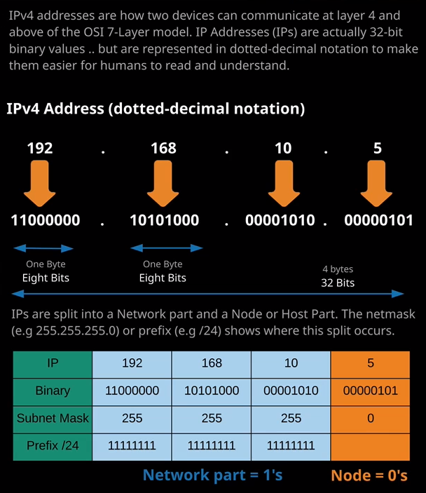

I'm going to focus entirely on IPv4. IP addresses are actually just 32 bit binary values, but most of the time they're not shown as that they're actually represented most of the time in dotted decimal notation, and that makes them easier to understand for humans. So you got a 32 bit binary number that's generally represented as four numbers. Each of these four numbers can be from 0 to 255 so a total of 256 values for each of these numbers. So, for example, 192.168.10.5 can be represented as this 32 bit binary value. So each of these segments, so each of the numbers that you see in an IP address is one byte. So eight binary bits each of these put together so all four of them makes one 4 byte, 32 bit binary value and each one of the's segments is called an octet because it's eight binary bits so there are different ways an IP address can actually be represented. Now you don't really need to know how to do this conversion from decimal to binary. It is something that I do recommend that anyone who is in the text base day to day learns how to do.

Now, IP addresses are actually split into two different parts the **networking part and then the node also known as a host part** and you wouldn't know looking at IP address, which component represents the network and which component represents the host. With this example 192.168.10.5 it might be that 192.168.10 is the network, and then five is for the node or the host or it could be that 192.168 is the network and then 10 and five or any other values in these spaces represents the node. Just looking at the IP address isn't enough information. **You need another value to be able to determine which part is the network and which part is the host and that's what the subnet mask or the prefix does that together with the IP address helps you split between the network and the host part.** The subnet mask tells the computer which part of the IP is for the network and which is for the nodes and this is what allows your laptop or computer to know if another IP address is on the same local network or not and that's important because whether a machine that you're communicating with is local to you on the same network or on a remote network changes how that communication happens, and it's important to understand how that works.

Now IP addresses are actually anywhere from 0.0.0.0. to 255.255.255.255. That actually represents over four billion IP addresses. It's four billion, 294 million, 967,296. That's total IP version four addresses, but some of them are actually special, and it will help you a lot in the exam and if you're using AWS in production to understand which the special IP addresses are.

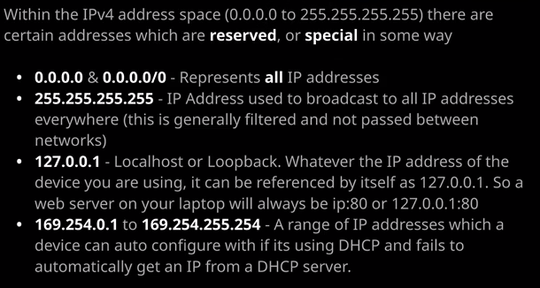

Now the first one I want to talk about is all zeros, so you'll see this represented 0.0.0.0 or 0.0.0.0/0 and that's just a short hand way to represent all IP addresses. So if you ever see that, it essentially means all IP addresses the entire IP version four address space.   
The next one is 255.255.255.255 and this is a special IP address that could be used to broadcast to every single IP address everywhere but it's worth keeping in mind that this is actually filtered and not passed between networks. So once the internet became the size that it was network administrators started to implement filters which prevented this broadcast address from crossing network boundaries. You can no longer use this to broadcast every internet IP address, but in theory that's what it would do if there wasn't this filtering in place.   
The next is 127.0.0.1 and this is known as the local host or loop back address. Whatever the IP address of the device that you're using, it can be referenced by itself as 127.0.0.1. So if you're running a web server on your local laptop, maybe you're doing some development testing or maybe you're studying for something if you're doing that, you can either reference that web server as your real IP address :80 or 127.0.0.1:80. So this will only ever work on your local machine to reference itself but it will work anywhere. So any IP capable machine can use this IP reference itself.   
Next, we've got 169.254.01 to 169.254.255.254 and this is a range of IP addresses. Now this range is used if DHCP ever fails. DHCP is a protocol that allows your laptop or your mobile phone or your tablet to automatically configure itself with an IP address. So if you're logged on to your home WiFi network and you've got your internet router, this internet router will generally automatically allocate IP addresses to any devices on your local network. If that process ever fails, but your phone or tablet or computer tries to use it to get an IP. It will be automatically configured with an IP in this range. Now that will generally mean that it won't work but it's a way that the computer can always ensure the does have an IP address, even if it's not a valid one.

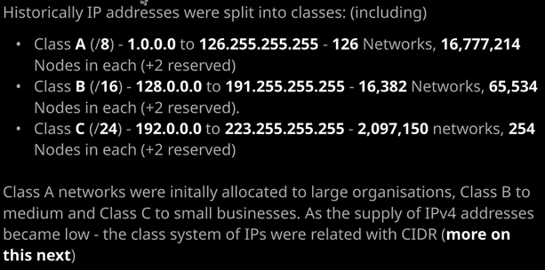

Now, the next thing I want to talk about is IP address classes. So historically, we've got this full IP address range and this is over four billion IP addresses. Now, in the early days of the internet, this was actually split up into a number of different groups and these groups were used to give IP addresses to huge businesses, medium businesses, and small businesses. It was actually a very inefficient way of handing out IP addresses. Now in this lesson so I'm going to talk about Class A, B, and C. There are others there are D and E, but they're not relevant to AWS and especially the associate level studies. So I'm going to focus on these. Even these have been deprecated preferencing something else I'm going to talk about soon, but it's worthwhile knowing exactly how this class system works.

So this entire range zeros to 255s. The first class that was created was a Class A and that's known as a /8. Now **Class A went from 1.000 all the way through to 126.255.255.255. So these Class A's were only ever given out to huge organizations and even then only at the very start of the internet being created when people didn't really think we could run out of IP addresses. So this class A consisted of 126 networks, so essentially it was each individual first octet.** So one, two, three all the way through to 126 each of these networks had 16.7 million available IP addresses inside it so you can have up to 16 million nodes or hosts and again, these were only ever given to huge organizations.

We also got class B known as /16 and this class went from 1 to 8 and then zeros to 191 all 255s. Now inside this class there are a total of 16,382 networks. Each network was essentially one unique copy of these first two numbers. So 128.0, 128.1, 129.0, 129.1, and so on. It had 16,382 networks, and each of those networks had 65,534 nodes.

The other type of class that I want to talk about is a Class C. These were given to smaller organizations, so these are represented as a /24. This range went from 192.0.0.0 to 223 and then all 255. So each Class C network was a unique combination of the first, second, and third octets. So 192.0.0 was one network 192.0.1 was another network, while 192.1.0 was another network and so on. So you had 2,097,150 of these networks and in each of these networks there was enough address space for 254 nodes and then, of course, the two reserved addresses, so total of 256 IP addresses.   
Now Class A networks were initially allocated to huge organizations, Class B to medium, Class C to small but as the supply of IP version four addresses became low, this class system was replaced with a new system called C-I-D-R or CIDR but more information on this soon.

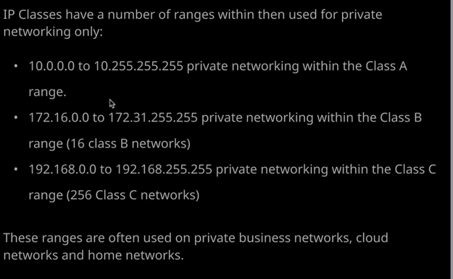

Inside each of these ranges, we've also got a **private address space.** So normally IP version four address spaces are public and that means if you've got a public IP address, and I do in all likelihood, we can communicate over the public internet but there are some IP address ranges which are private and these are generally used within private business networks or data centers where they don't need to natively communicate with the outside world. The benefit of this is that these could be duplicated. So there's nothing wrong with you using this private address range and me using the same range because there are other products and features that allow these ranges to communicate to the internet. I'll be talking about those later in the course but for now, just keep in mind that these addresses are private. They can't be used directly on the public internet. So first we've got the Class A private range. So that's 10.0.0.0.0 to 10.255.255.255. So this is a single range that you can use and carve up however you need inside your organization. We've also got this Class B range. This is 172.16.0.0 to 172.31.255.255. So this is actually 16 individual Class B networks, so 172.16 and 172.17 and so on and then each of these has obviously got 65,000 IP addresses inside. Lastly, we've got a Class C private range, which is 192.168.0.0 to 192.168.255.255. So this is a total of 256 networks. So 192.168.0 or 192.168.1 and so on, all the way through to 255 for a total of 256 networks. Inside each of these networks, 254 hosts with two extra reserved addresses. So these are the private ranges and these the ranges that will generally be used inside AWS, Azure, or the Cloud environments and lots of private business networks globally. You can use these however you want. You don't have to apply for them. You don't have to be allocated for them, and you can carve them up inside your network however you want.

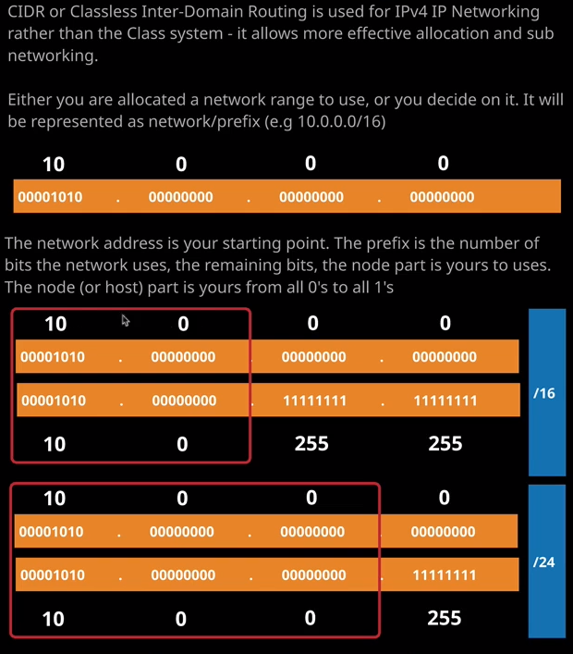

Lastly, I want to talk about **CIDR and this is classless interdomain routing**. Now this is used for IP version four networking rather than this class system. So the class system was actually really inefficient to allocate and carve up these address ranges. If you wanted to give a large organization IP addresses, you only have two choices a Class A or Class B, nothing in between and a small organization could only have a Class C, and if you wanted to give it more then you have to get a Class B, there was no flexibility. **CIDR allows you to decide to use or be allocated a wider range of sizes of networks and what's more, you can choose to subdivide these networks as you need inside your business**. **With CIDR we use what's known as IP network and prefix notation.** In AWS, for example, you might decide to use 10.0.0.0/16 or 10.0.0.0/24. These are completely different, and you need to know the difference. Now the IP address in that notation so 10.0.0.0 that's called the network address. It's the starting point for a range of IP addresses, So in this case, you might be allocated 10.0.0.0/16 the /16 which is known as the prefix tells you which part of the IP address is for the network and which part is for the node or hosts, and that's why it's so important to understand how this works. So in this example, we have 10.0.0.0/16 The 16 tells us that the first 16 binary bits are for the network so in this case, that means that 10.0 represents one network and because of that, we know that 10.1 represents another, 10.2 represents another, and so on. So by knowing the /16 and knowing the starting point, we know where our network starts and where another network begins. So with /16 anything other than what we have for these first 16 bits is not our network. So our network is 10.0 which is 00001010 and then all zeros. Anything other than that is a different network. So we're just having this networking address in this /16. We know where our network begins and how to tell where other networks begin but by having this 16 we also know that anything beyond this first 16 bits is ours to use as we want. So we know that from all zeros to all ones is our network. So 10.0 and then 00 all the way through to 10.0 to all ones so 255.255. So if you use a /16 we know that we've got this large address space but let's have a look at how that differs with a /24. With a /24 we know that our network starts from 10.0.0.0 and the /24 is 24 bits of network address. So all of this is the network. That means that anything in this first component so anything different for networking component is a different network. So 10.1 would be different. 10.2 would be different and so on. So essentially our network is 10.00 and then anything from 0 to 255 is ours to do with as we wish, so you'll see the difference. A /16 gives us a lot more host or node space to deal with than a /24 does and you'll see in the upcoming lessons it becomes possible to subdivide whatever we're given into smaller individual networks. So in a /16 you'll have a lot more usable capacity than a /24 and later in this course, we'll see how you can create a VPC using this networking range and then subdivide it into different subnets by using a process called subnetting and I'll explain how that works in this topic of the course. Now again, don't worry if this seems confusing, it's actually a really complicated topic to understand. I just want to give you this initial exposure, and then throughout the course, I'll be demonstrating how it works in practice.